Rubrics

# Evaluation topics

Before handing in your group assignment, you can check which points will be assessed in this evaluation. To see this, you need to click on ‘View Rubric’ when you have opened the assignment.

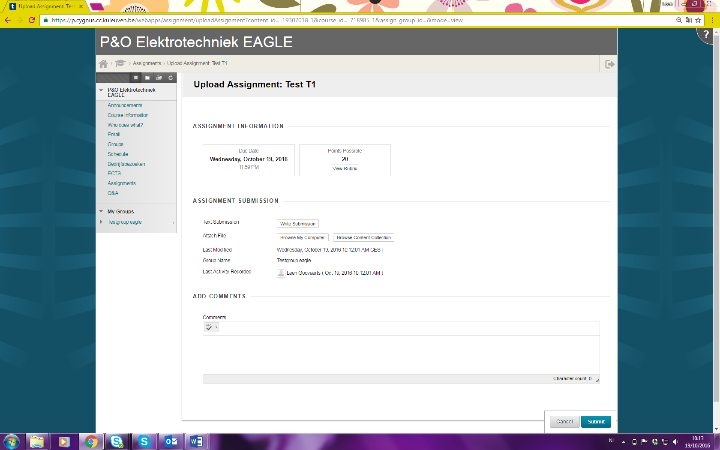

The rubric used for this evaluation will appear. For example:

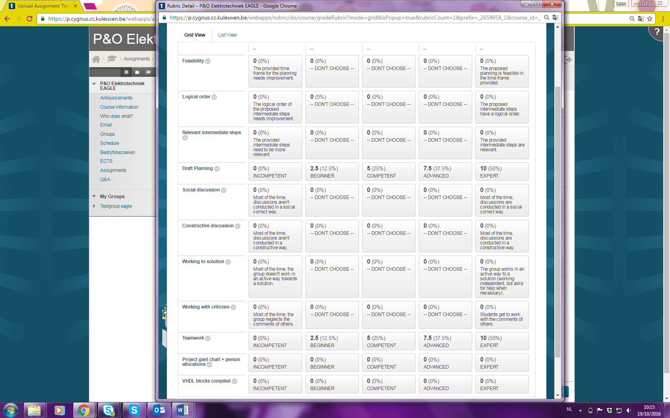

When your teaching assistants have assessed you, you’re able to recall this rubric, with the received scores and feedback, as explained below.

# Receiving feedback

When your teaching assistants have assessed you, you’re able to see the grade of your group and the feedback. For seeing this, select the assignment you want to see. In this assignment, you now see your grade. By selecting the grid, you get more detailed information in the rubric, with feedback.

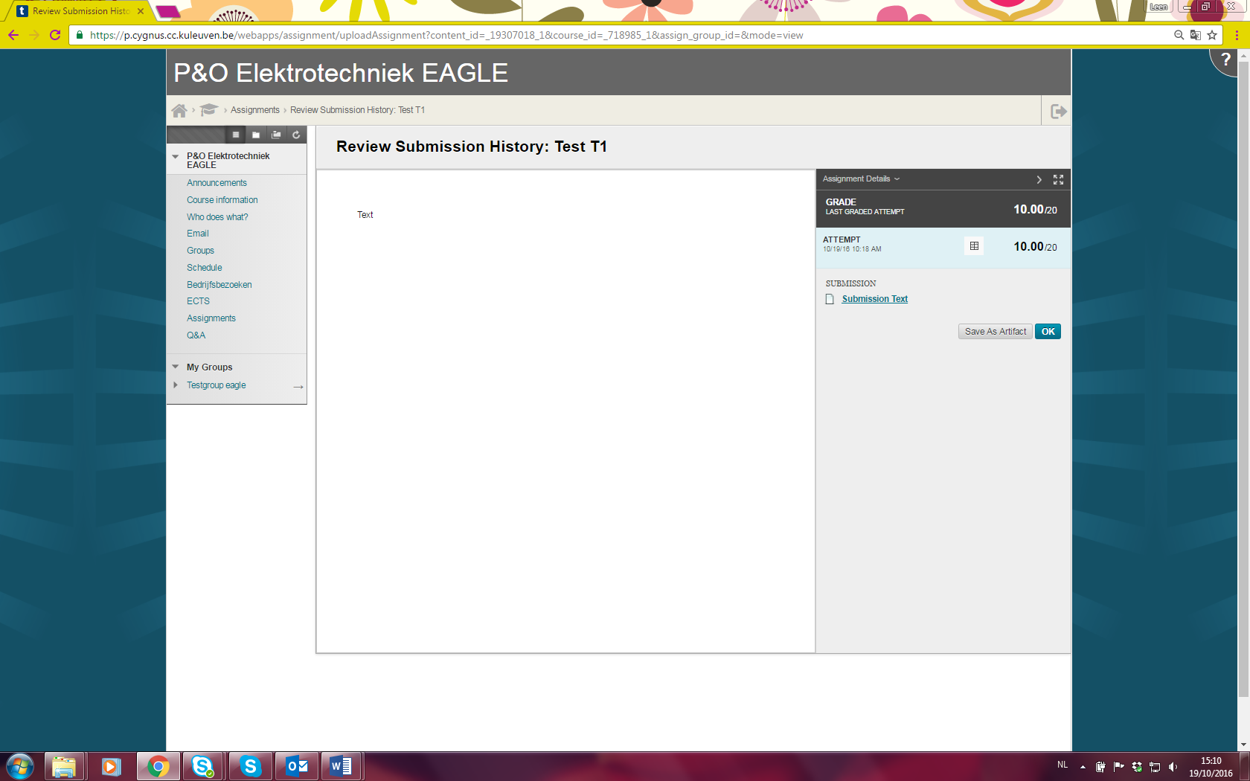

Select the prof who coaches your team.

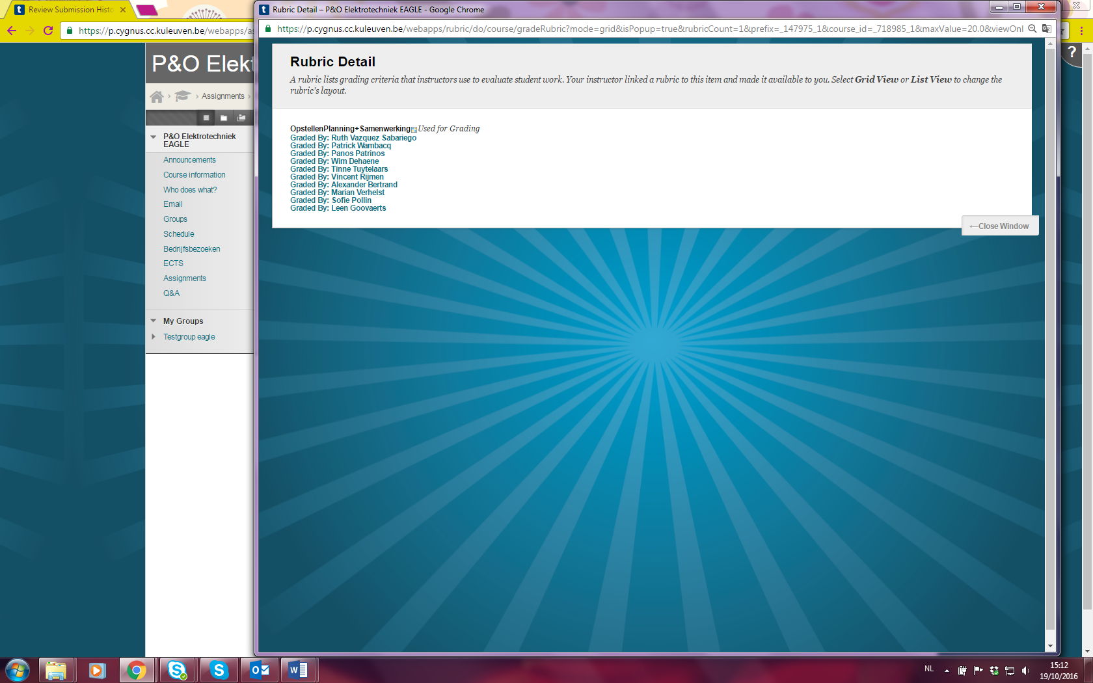

The filled in rubric with feedback will appear.

